**Lab MST Worksheet - 1**

**Student Name:** Vivek Kumar **UID:** 21BCS8129

**Branch:** BE-CSE (LEET) **Section/Group:** ON20BCS-809/A

**Semester:** 4th Sem **Date of Performance:** 21/03/2022

**Subject Name:** MPI Lab **Subject Code:** 22E-20CSP-253

**1. Aim/Overview of the practical:**

Write an assembly language program in 8085 microprocessors to subtract two 16-bit numbers.

**2. Task to be done:**

a) Write the program to calculate the subtraction of two 16bit numbers.

b) Add the screenshot of the output.

**3. Apparatus/Simulator used (For applied/experimental sciences/materials-based labs):**

1. 8085 Jubin simulator version 2 (Microprocessor Simulator)
2. Java (jdk/ jre1.8.0_321) or any

**4. Algorithm/Flowchart (For programming-based labs):**

**Subtraction of two 16bit number**

1. Load the 1st pair number from memory location 3000,3001 to HL pair.
2. Exchange it with the DE pairs.
3. Load the 2nd pair number from memory location 3002,3003 to HL pair.
4. Move the content from E to accumulator.
5. Subtract the L from accumulator.
6. Move the content from accumulator to L register.
7. Move the content from D to accumulator.
8. Subtract the H from accumulator with the borrow.
9. Move Accumulator to H register.
10. Move the content of HL pair Register to memory location 1004,1005,
11. Exit the program.

**5. Description/ Code:**

**Subtraction of two 16bit number**

# ORG 2000H

LHLD 3000

XCHG

LHLD 3002

MOV A,E

SUB L

MOV L,A

MOV A,D

SBB H

MOV H,A

SHLD 1004

HLT

# ORG 3000H

# DB 42, 35,34,21

**6. Result/Output/Writing Summary:**

**Subtraction of two 16bit number:**

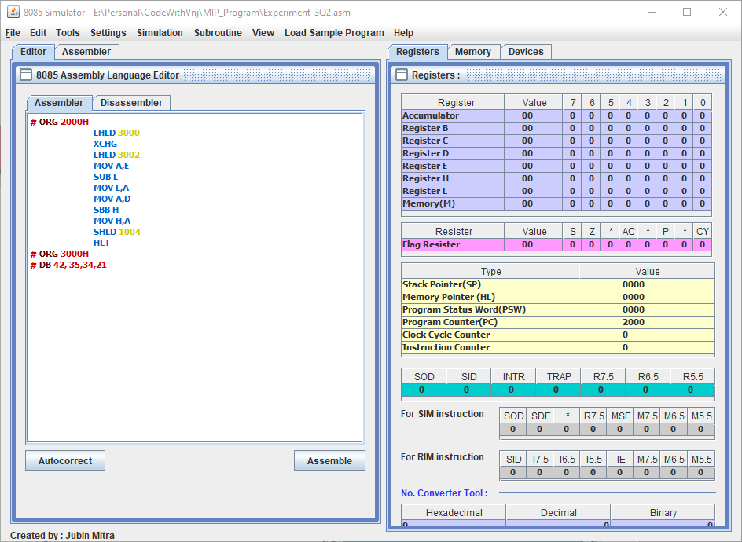

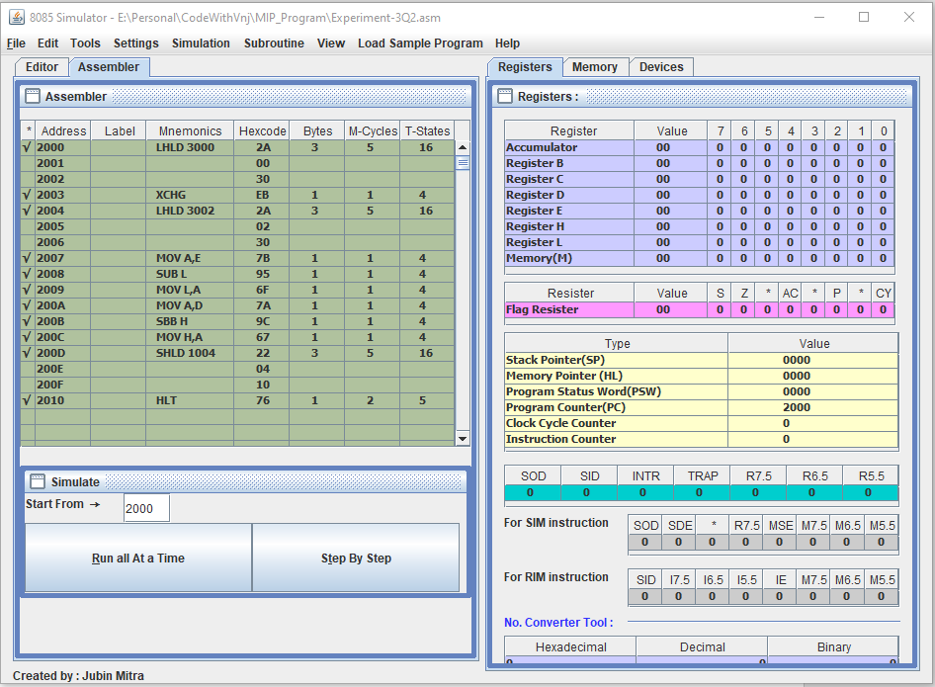

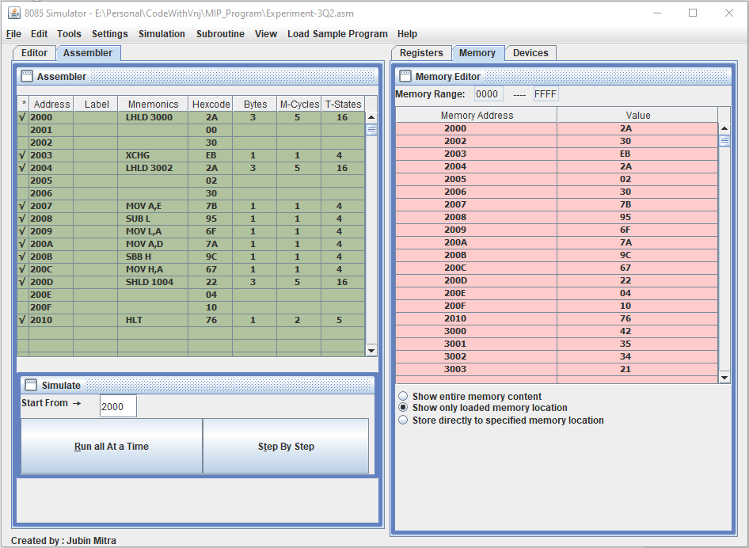

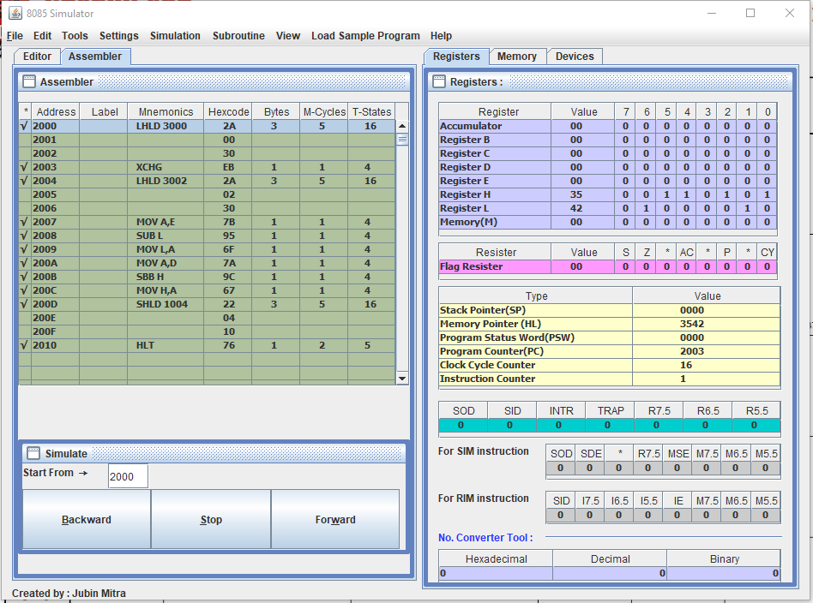

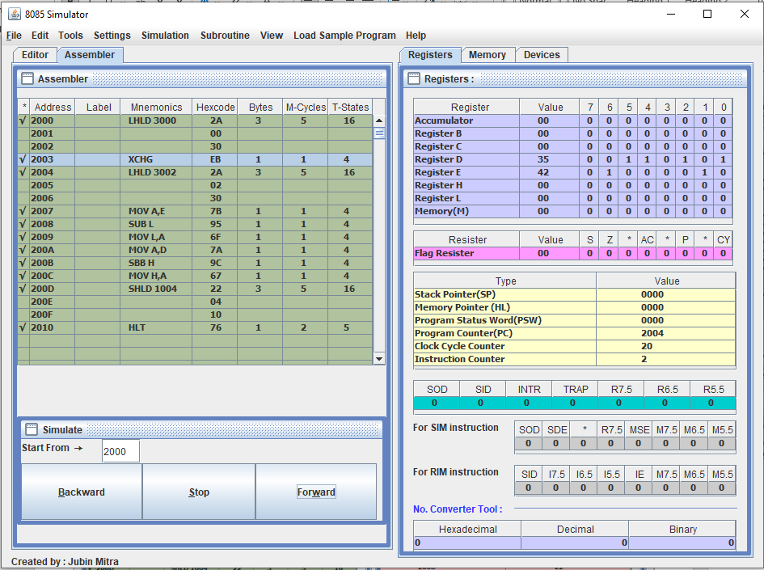

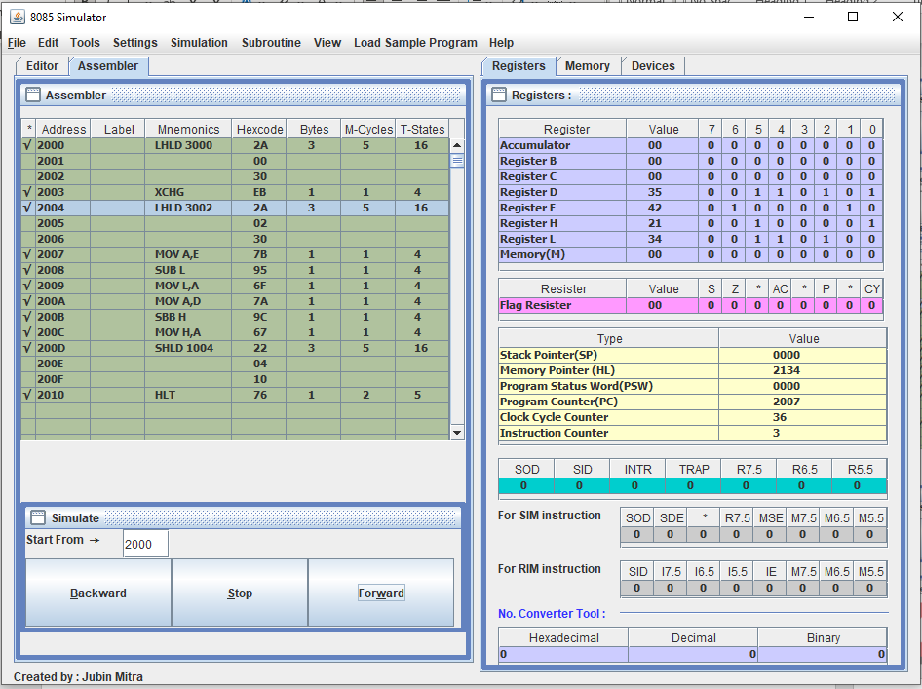

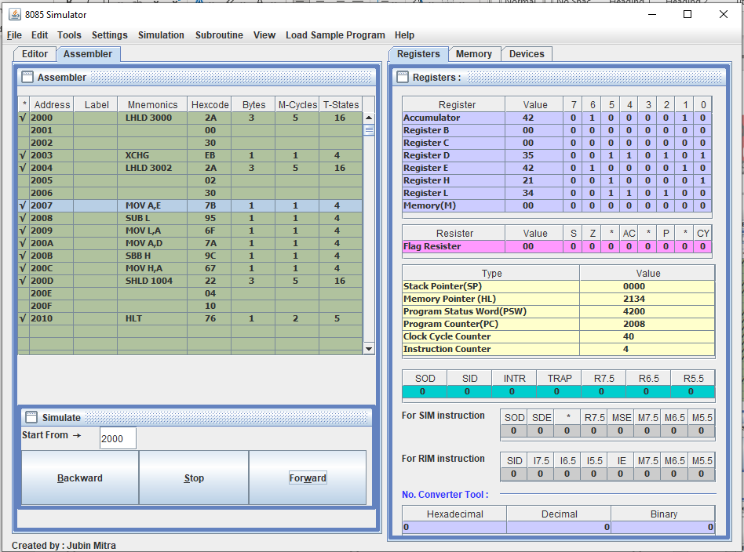

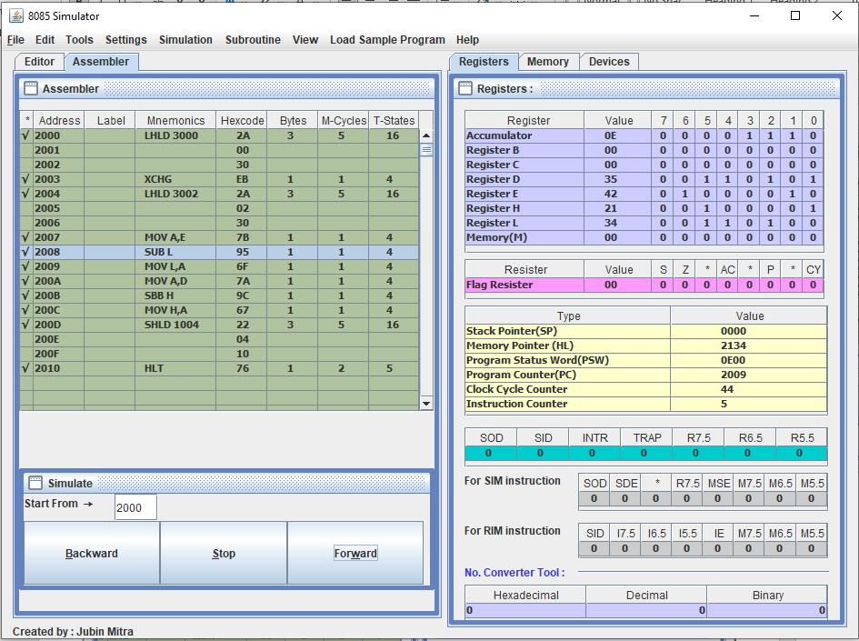

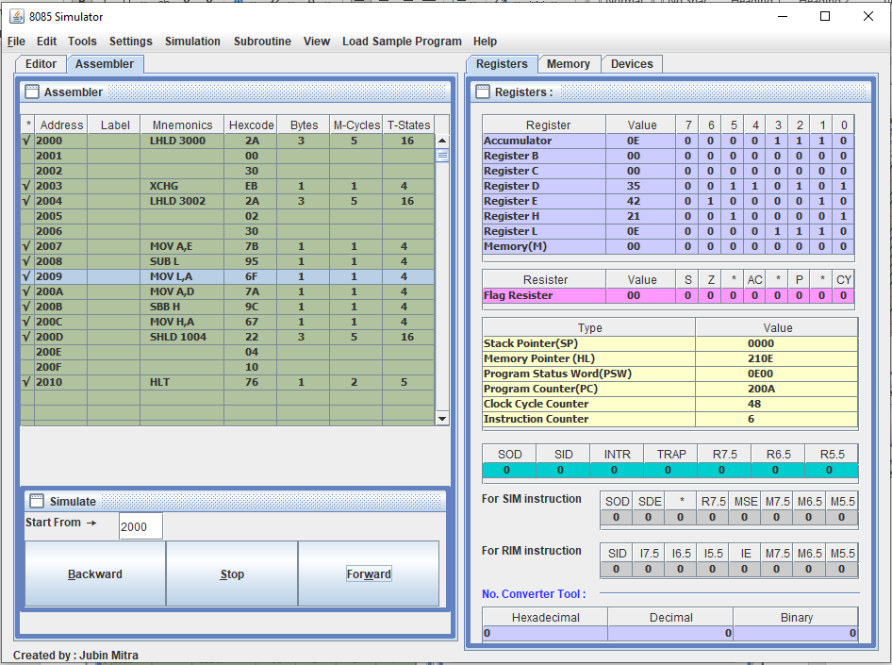

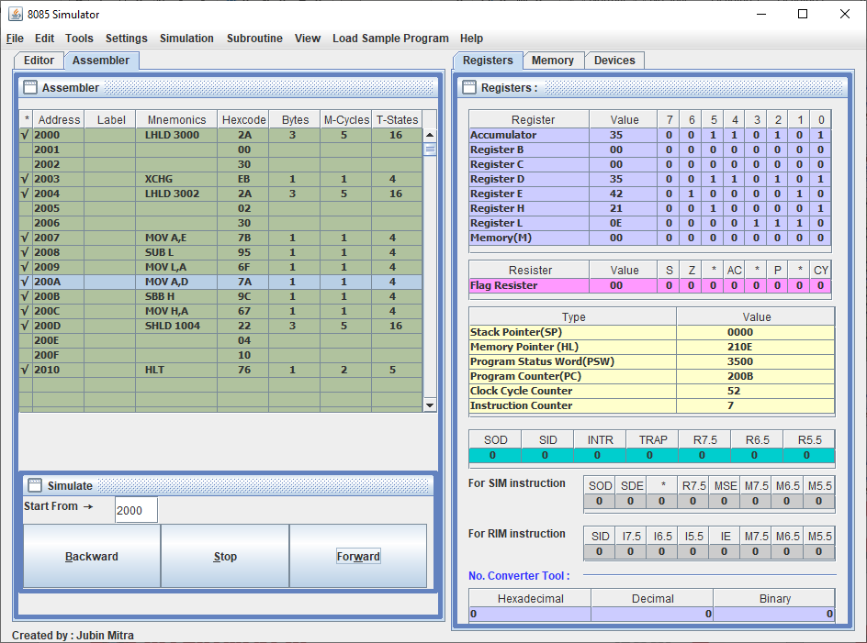

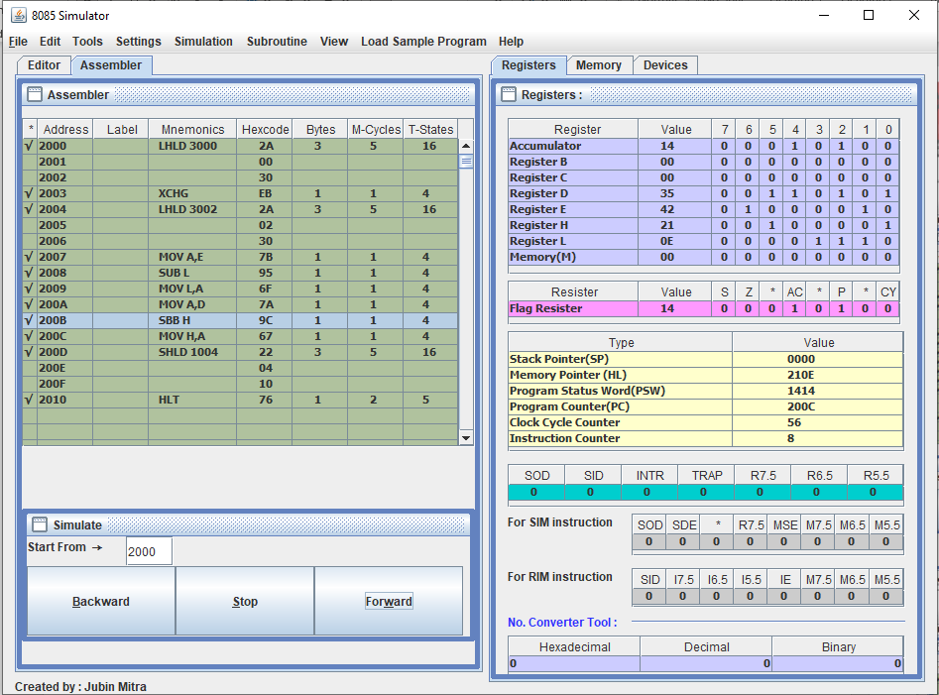

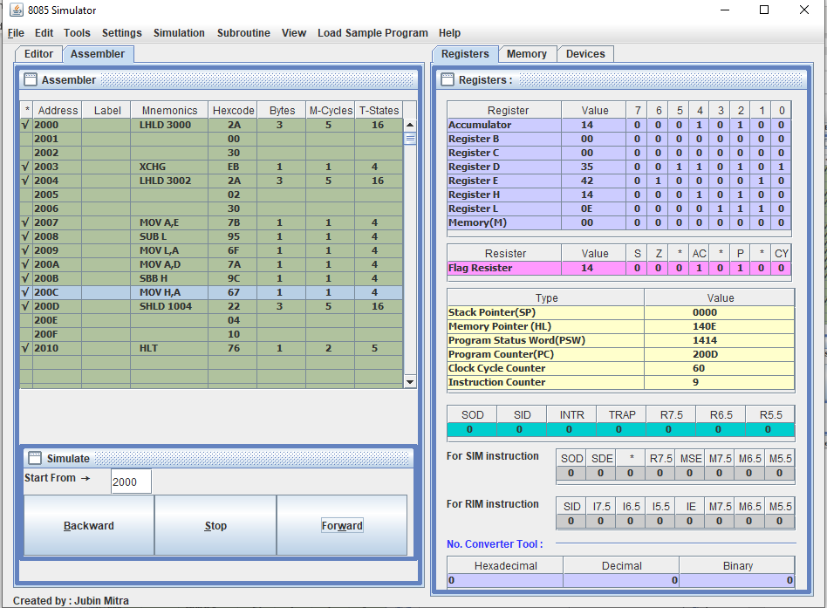

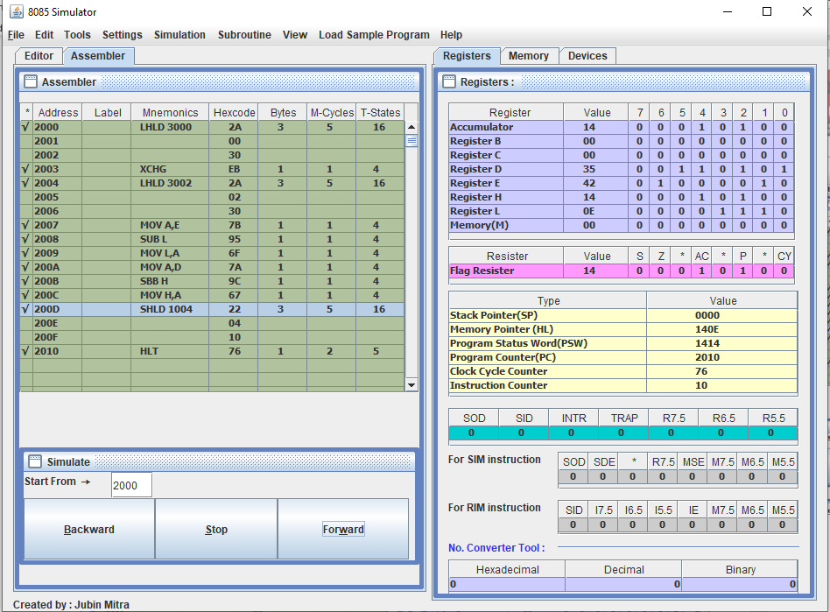

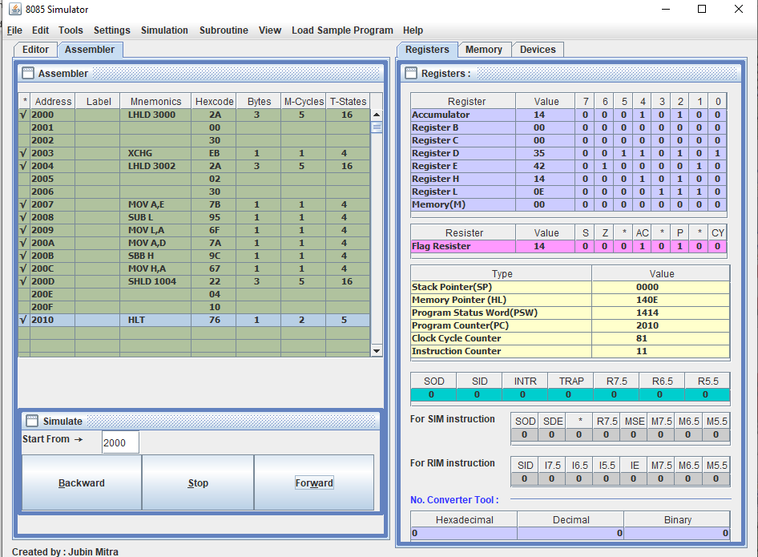

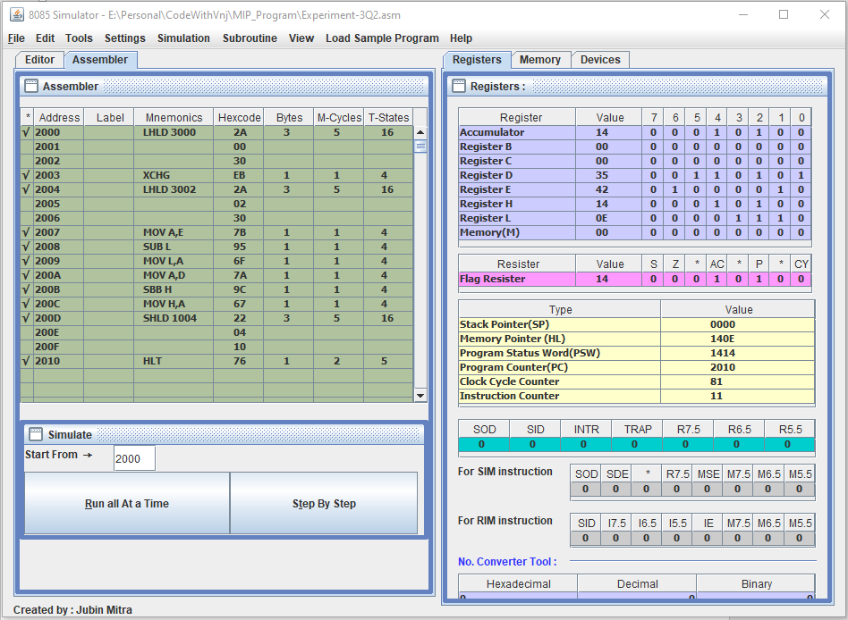

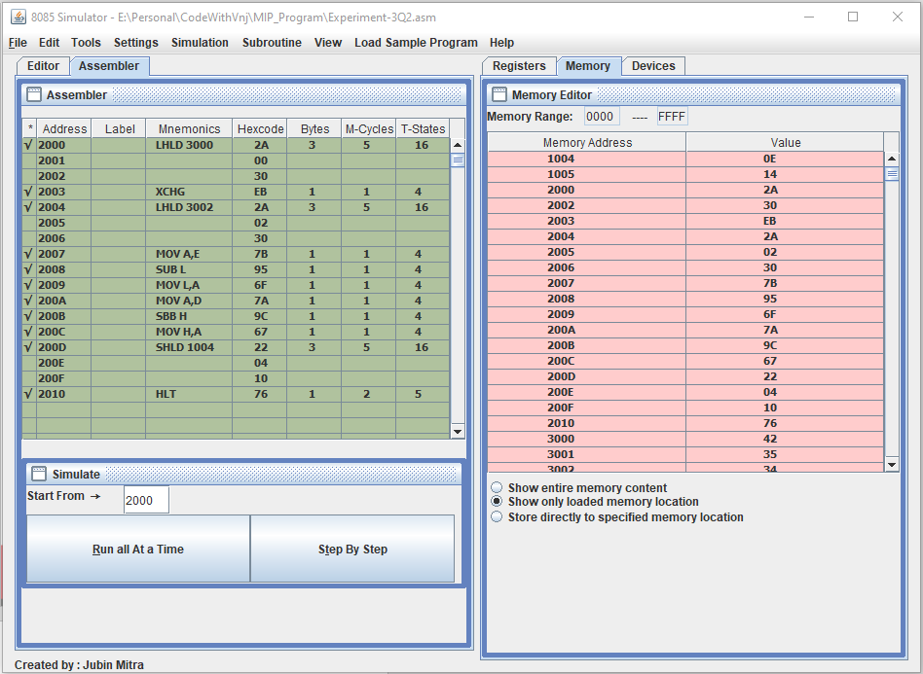

**Learning outcomes (What I have learnt):**

**1.** Learnt how to do the 8085-microprocessor programming.

**2.** Learnt how to Subtract the two 16bits numbers in assembly language.

**Evaluation Grid (To be created as per the SOP and Assessment guidelines by the faculty):**

|  |  |  |  |
| --- | --- | --- | --- |
| Sr. No. | Parameters | Marks Obtained | Maximum Marks |
| 1. |  |  |  |
| 2. |  |  |  |
| 3. |  |  |  |
|  |  |  |  |